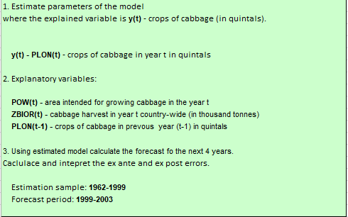

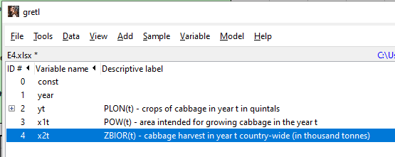 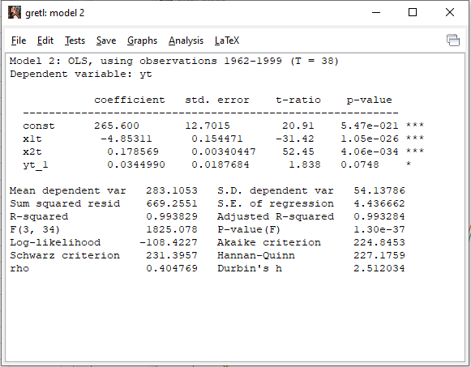

Interpretation :

**X1(t) :** If the area intended for growing cabbage in year increase by 1 unit, the crops of cabbage will decrease by 4.853 quintals

**X2(t)** : If the cabbage harvest in year t country-wide increases by 1 unit, the crops of cabbage will increase by 0,178 quintals

**Y(t-1)** : If the number of crops in the previous year increase by 1 quintal, the crops of cabbage this current year will increase by 0,034 quintals

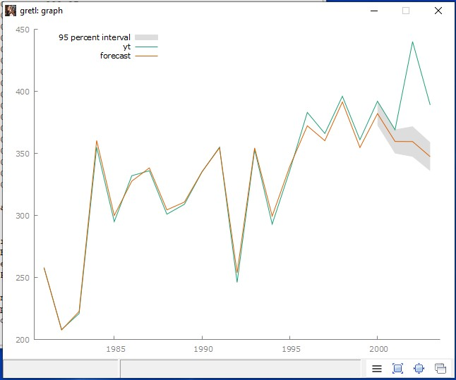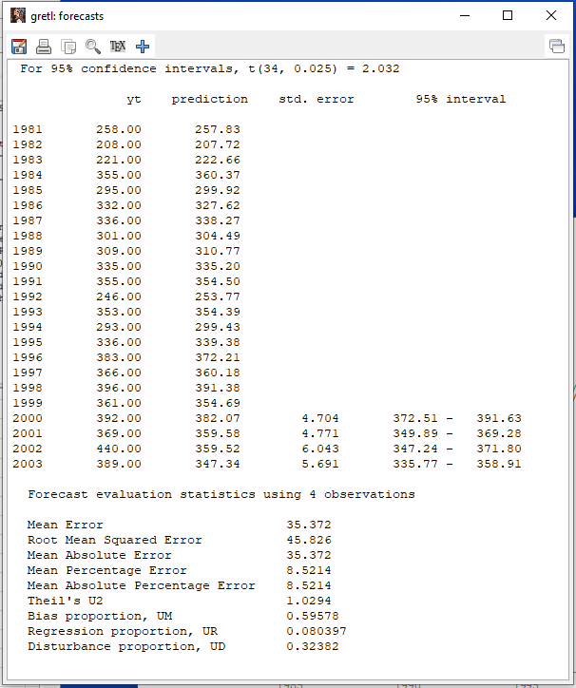

**Interpretation for forecasting:**

* from the data 2000, the difference is 10.07 quintals or 2,57%

* from the data from 2001, the difference is -9,42 quintals -2.55% * from the data 2002, the difference is -80,48 quintals -18,3%

* from the data 2003, the difference is -41,66 quintals or -10,7%

* in conclusion that this data the error is increase by year and the biggest is in 2003 with an 18% difference